Normalization

Defination:-

* Normalization is the process of organizing the data and the attributes of a database.
* It performed to reduce the data redundancy in a database and ensure that data is stored logically.
* Normalization is multi -step process that puts data in tabular form and remove duplicate data from relation tables.

Types of Normalization:-

1. 1NF(First Normal Form):-

A relation is in 1NF if it contains an atomic value.

1. 2NF(Second Normal Form):-

A relation will be in 2NF if it is in 1NF and all non-key attributes are fully functional dependent on the primary key.

1. Normal 3NF(Third Form):-

A relation will be in 3NF if it is in 2NF and no transition dependency exists.

1. BCNF(Boyce-Codd Normal Form):-

A stronger definition of 3NF is known as Boyce Codd's normal form.

1. 4NF(Fourth Normal Form):-

A relation will be in 4NF if it is in Boyce Codd's normal form and has no multi-valued dependency.

1. 5NF(Fifth Normal Form):-

A relation is in 5NF. If it is in 4NF and does not contain any join dependency, joining should be lossless.

Diagram of Normalization:-

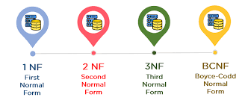

Advantages of Normalization:-

* Normalization helps to minimize data redundancy.
* Greater overall database organization.
* Data consistency within the database.
* Much more flexible database design.
* Enforces the concept of relational integrity